IdeationPhase DefinetheProblemStatements

|  |  |
| --- | --- |
| Date | 19 October 2022 |
| Team ID | PNT2022TMID39156 |
| ProjectName | Skill/JobRecommender Application |
| MaximumMarks | 2Marks |

CustomerProblemStatement:

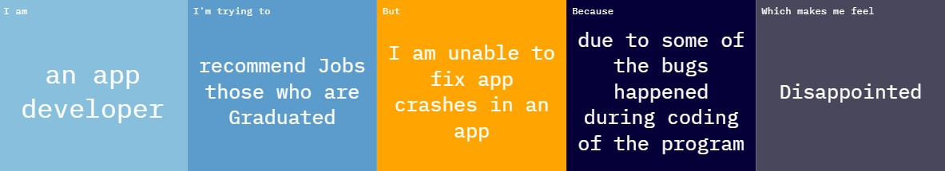

|  |  |  |  |  |  |
| --- | --- | --- | --- | --- | --- |
| Problem  Statement  (PS) | Iam  (Customer  ) | I’mtryingto | But | Because | Which makes me feel |
| PS-1 | An app  developer | Recommend jobs those who are  graduated | Iam unable to fixapp crashes in an app | Dueto some of the bugs happened during coding of the program | Disappointed |